***IS Project presentation***

Project idea :

Car AGANS

The attributes:

* Car model Name
* Car model year
* Employee ID
* Employee Name
* Employee address
* Employee age
* Employee phone number
* Car cost
* Car color

Operations:

Implementation of a project that presents the user with all the information about cars of all kinds and helps him to choose a type of car suitable for his desires or needs and also at an appropriate price

THE GUI :

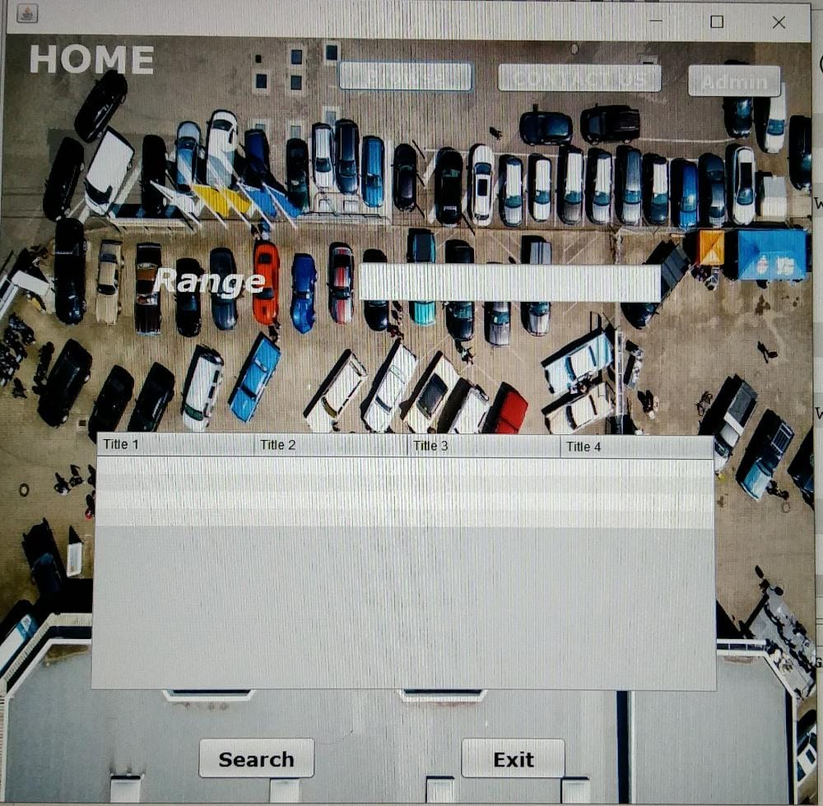

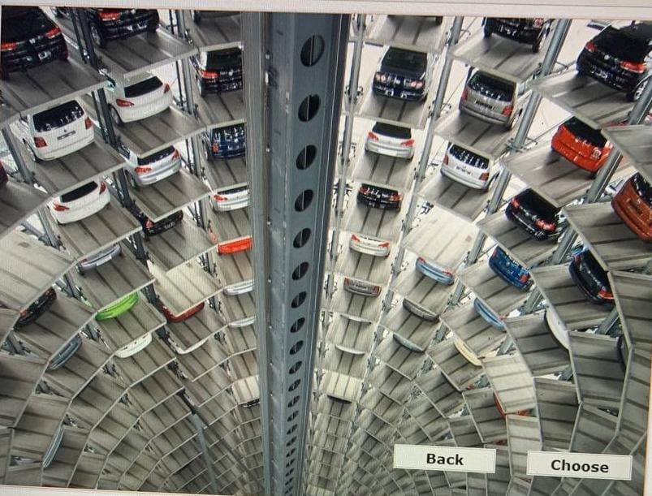

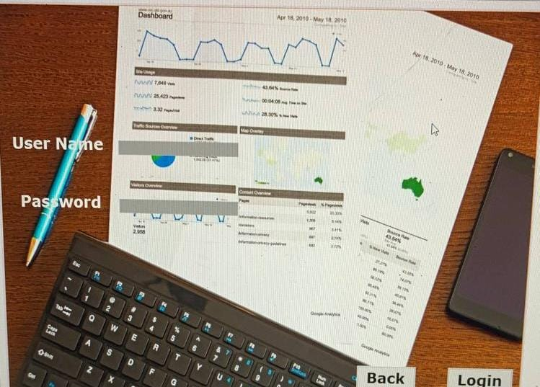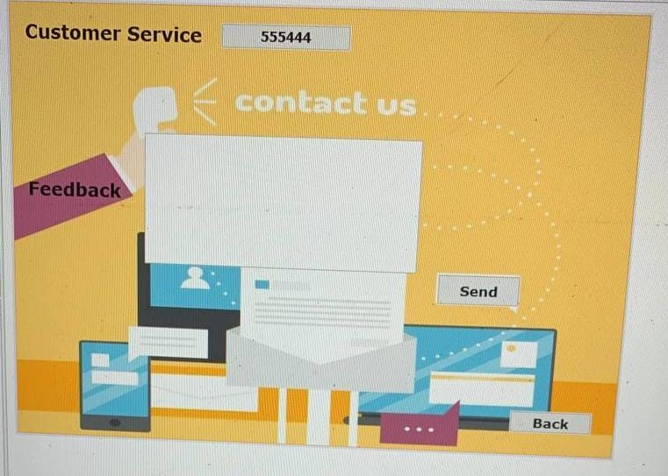

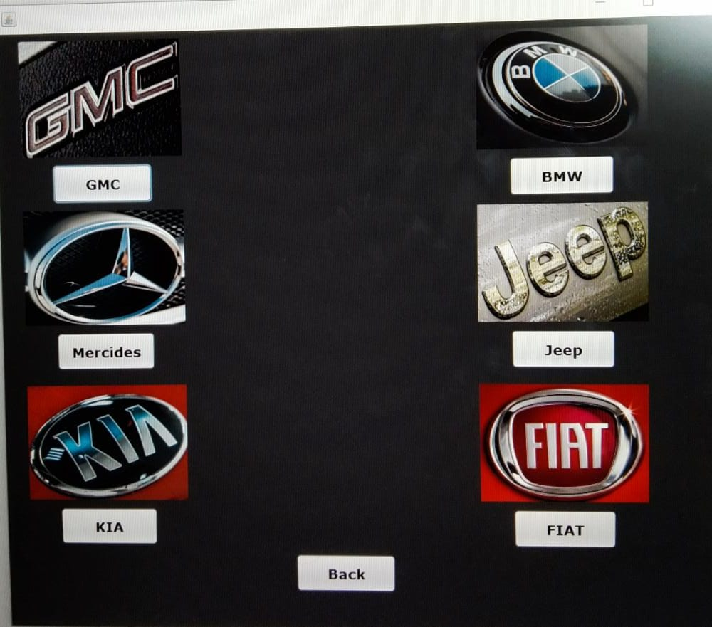

Team Members:

* Rawan Abdu–El Aziz Ahmed(team leader)
* Roaa Ayman Hassan
* Reham Tarek
* Zahrat-El Islam Nashaat
* Zyad Adel
* Zyad El-Sayed